**HOME AUTOMATION USING CISCO PACKET TRACER**

**This is the initial condition where all the devices are connected to the**

**HOME GATEWAY**

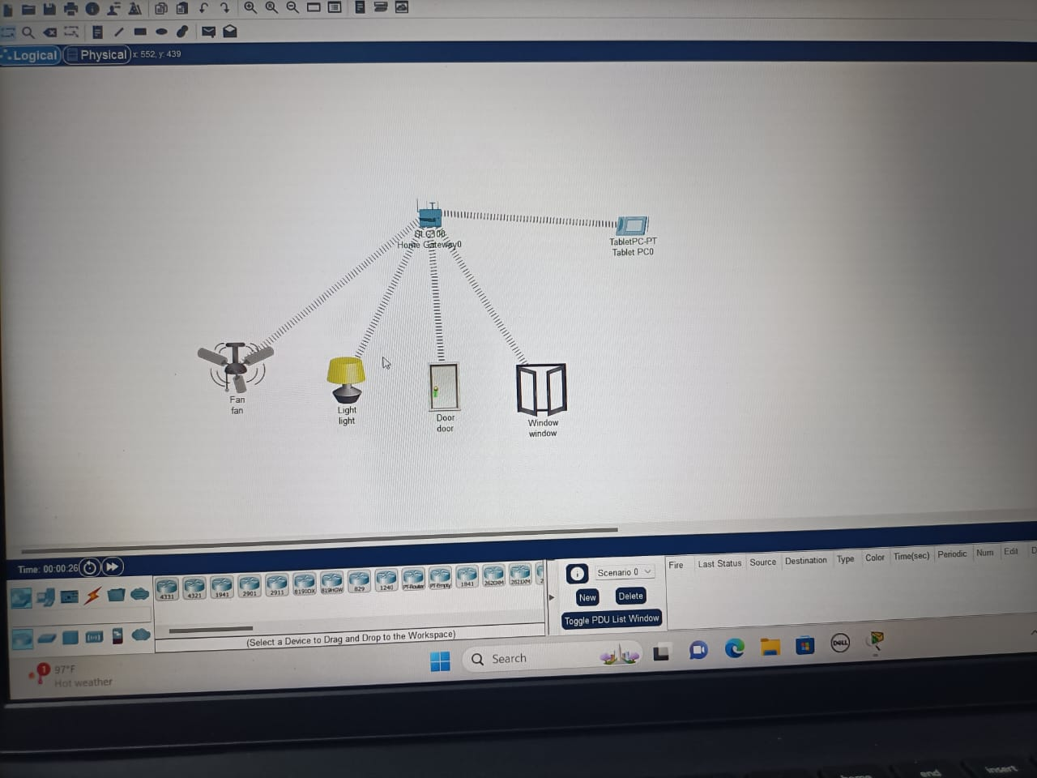

**Step-2:**

**Conditions are given to work accordingly.**

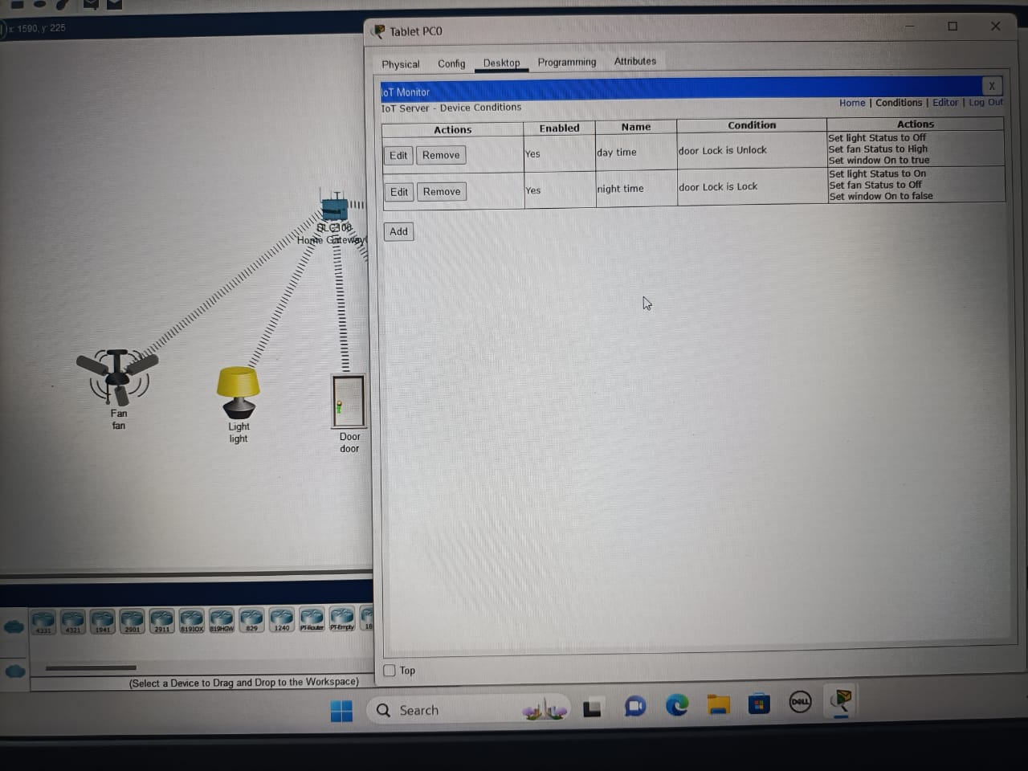

**Step –3:**

**When the door is closed – only the LAMP is switched on and all**

**others are turned off automatically.**

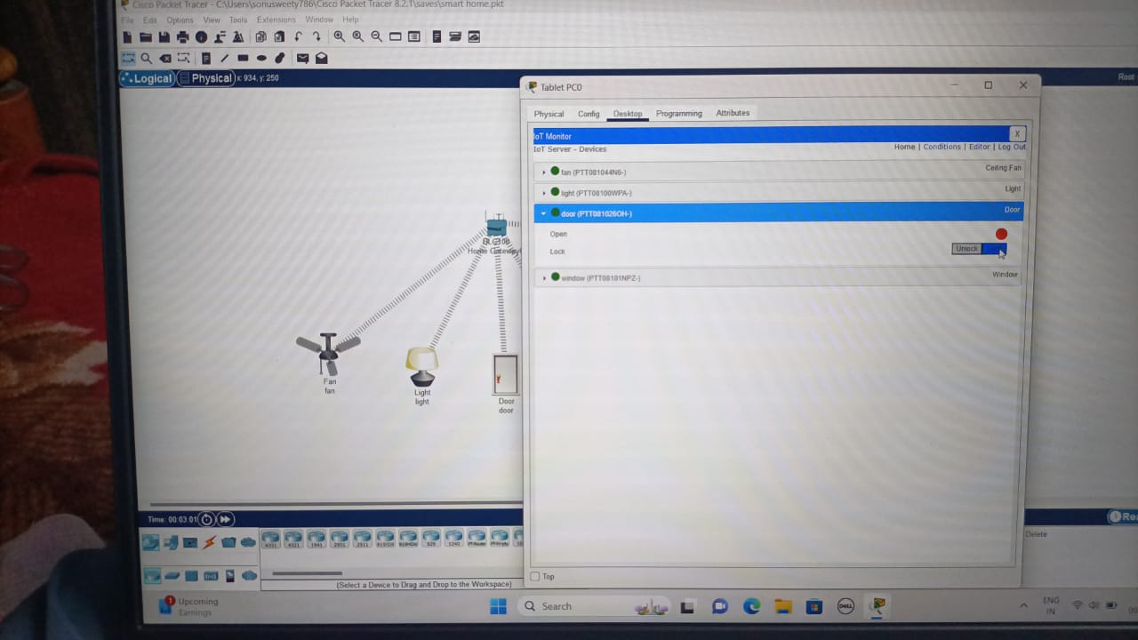

**Step-4:**

**When the door is open- the fan and window will be operated and opened automatically and light will be switched off.**

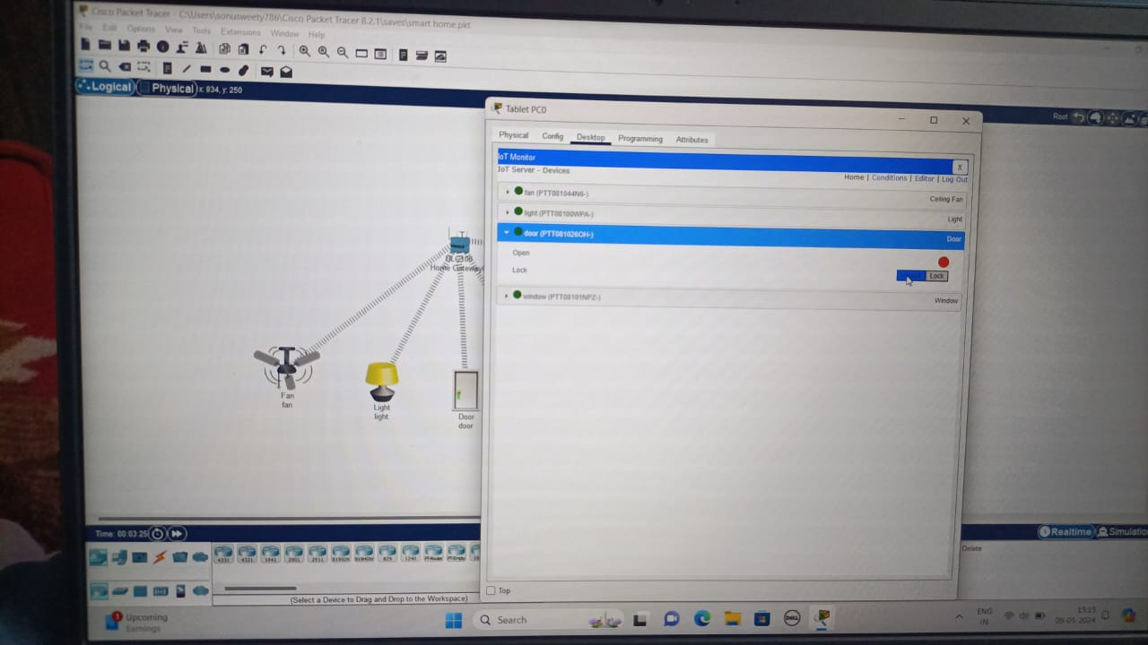

**CONCLUSION:**

Home automation offers convenience, efficiency, and security by integrating smart devices and technology into our living spaces. With features like remote access, energy management, and automated routines, it enhances comfort and simplifies daily tasks. As technology advances, the possibilities for home automation continue to expand, promising a future where our homes are more interconnected and responsive to our needs.

**LICENSE PLATE RECOGNITION SYSTEM**

**STATEMENT:**

Providing a process flow for license plate recognition system for a IT park , where the safety team needs to monitor the number plate.

**FLOWCHART:**

